Diploma in Software Engineering and Design

Assignment Cover Sheet

Course name:  Diploma in Software Engineering and Design | Student’s name:
Module Name /or number: Computer Programming 1
Assignment title and/or number: C#.Net Assessment

Assessment weighting | 15 credits,  12.5% of the overall programme.
Due date: 9th September 2016 | Date submitted:  (late submissions incur 10% penalty, after 7 days late, the assessment will not be marked)
Assessment conditions: | This is a resource-based assessment. This means that you may have access to any relevant resources to assist you. This could include, for example, your learning materials, information on the Internet, and so on. However, all work must be your own with no assistance from any other person.
Submission requirements: | You’re required to submit the following into your assignment submission directory:  - This document, completed where appropriate  - Visual Studio project files  GitHub link below:
Passing Criteria: | Need to score 50 or more marks to pass the assessment.  Total Marks : 100
Learning Outcomes: | - Develop computer programs in a GUI environment  - Demonstrate knowledge of data types and structures  - Demonstrate knowledge of user interface controls and user interface animation  - Design, develop and test a computer program  - Incorporate comments into code  - Compile, debug and test computer programs

Assignment Checklist:
  Requirement | Completed
  Database | ✓✗
  User interface | ✓✗
  Functionality | ✓✗
  Coding | ✓✗
  Testing | ✓✗

Disclaimer of Plagiarism and Collusion
I declare that, to the best of my knowledge, this assessment is my own work, and has not been copied from any other student's work or from any other source.
Enter your name here to indicate you agree to the above statement.

Assessment Overview
This project involves simulating a Russian roulette game using C#.net.
Functionality Requirements
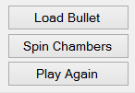
The program runs like this (with a button for each step)
- You load the bullet into the chamber of a revolver
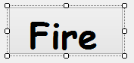
- You spin the chamber to create a random place where the bullet is with a 1 in 6 chance.
- You pull the trigger repeatedly until the gun fires through to the number where the bullet is stored.
- The player has 2 chances to shoot away during the game, this means that if the bullet is fired during that time they survive. If they shoot away twice and still the bullet has not been fired then the next shot they die.
Project Requirements
- Should simulate the game
- Use of appropriate data types and variables
- Appropriate User Interface(UI) design
- Creative and Intuitive UI (Reducing the possibility of human errors)
- At least one sound and image
- Sound and image should be loaded from the resource folder.
- All significant code to be commented
- User profile and a scoring system
- Include Win, Lose and Total scores
- Proper Testing performed and a testing sheet is included
- Project to be hosted on Github

Sample UI Layout
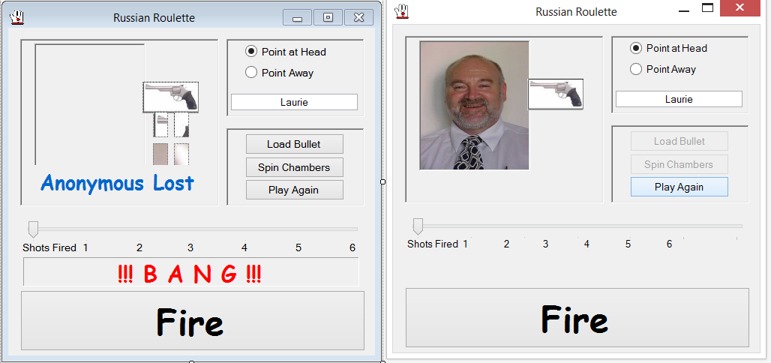

Testing Requirements

Testing assesses the quality of the product. Fill out the following testing sheet with the results of your test and submit it. The table below shows a sample testing matrix with a sample test scenario. Identify as many test scenarios as you can and test your software against it. Feel free to include additional columns or note points as you fix the bugs.
Functionality | Test Scenario | Expected Outcome | Actual Outcome | Result (Pass /Fail)
Fire Button | Pressing the Fire button:  - without choosing Point Away or Point at Head  - without loading a bullet  - without spinning chamber | Appropriate message shown in Message Box. |  | PASS  PASS  PASS
Fire Button | Disabling the Fire button:  - when chamber is spinning  - after shooting 6 times  - after bullet fired before the 6th time | Appropriate message shown in Message Box. |  | PASS  PASS  PASS
Load Bullet Button | Pressing the Load Bullet button:  - without choosing Point Away or Point at Head  - when clicked again in the same game session | Appropriate message shown in Message Box. |  | PASS  PASS
Spin Chamber Button | Pressing the Spin Chamber button:  - without choosing Point Away or Point at Head  - without loading a bullet  - when clicked again in the same game session | Appropriate message shown in Message Box. | Appropriate message shown in Message Box.  Appropriate message shown in Message Box.  The message won't appear after several clicks, need's deeper look | PASS  PASS  IMPERFECT
Play Again button | Functionality:  - Resets previous game calculations/variable values for a fresh start in the same session. |  |  | PASS
Play Again button | - Pressing it before finishing the current game | Appropriate message shown in Message Box. | Appropriate message shown in Message Box. | PASS
Check Score button | - Opens another form display the score in Data grid view | Opens another form display the score in Data grid view | Opens another form display the score in Data grid view | PASS
Exit button |  | Exit the Application | Exit the Application | PASS
Messages Text Box |  | Displays appropriate guiding message to the player during game play | Displays appropriate guiding message to the player during game play | PASS
Images and Sounds | Upon button clicks  Upon programed results | Display the appropriate images and sounds upon button clicks and code execution | Display the appropriate images and sounds upon button clicks and code execution | PASS
Trigger Count Progress Bar | Through game progression | Show the number of shots used and shots remaining | Show the number of shots used and shots remaining | PASS

Code quality checklist
Code quality is important for Maintainability and Testability of a software project. Refer to the code checklist below and check if your code meets the standards specified. (The code checklist given below are very general and some points may not apply to your project)
Code Formatting
- ✓Standard language indentation, spacing & bracketing?
- ?No tabs, only spaces?
- ✓No lines longer than 80 characters?
- ✓Good spacing between function bodies?
- ✓Avoids functions longer than a page?
- ✓Uses vertical alignment to enhance readability?
- ✓ Well spaced, clean & clear? Neatness counts!
General Code Quality
- ✓Good class names?
- ✓Good function/method names?
- ✓Good variable names?
- ✓Easily understandable?
- ✓As simple as possible?
- ✓Follows principle of least astonishment?
- ✓Extracts commonality & minimizes duplication?
- ✓No unnecessary cuteness or cleverness?
- ✓Proper names for Controls, Forms (txtName , lbluser etc.)
Comments
- ✓Explains anything that is non-obvious?
- ✓Could come back & understand in 10 years’ time?
- NAUnfinished parts marked with TODO?
- NABroken/incorrect parts marked with FIXME?
Error Handling
- ✓Proper message boxes added
- ✓Considers corner cases, worst case scenarios?
- ✓Checks for all possible failures?
- ✓Catches all possible exceptions?
- ✓All paths through the code tested?
- ✓All error paths tested if possible?
File Handling
- ✓Good filenames?
- ✓Following project's conventions?
- ✓Correct locations?
- NACorrect permissions?

Marking Schedule
The table below shows a summary of the breakdown of marks. A detailed breakdown is given in the next section.
Points Assessed | Marks
User Interface  Functionality  Coding  Testing | 20  30  40  10
Total | 100

Detailed Marking Schedule
% of Grade | Excellent 100% | Adequate 80% | Poor 60% | Not Met 0%
User Interface  20% | Simple easy to use intuitive UI, no errors spelling mistake and good colour schemes used | Minor errors with the UI, minor layout issues | Major UI errors making it hard to understand. High possibility of human errors. | Significant UI errors with no logical sense and frequent UI issues
Functionality  30% | No errors, program always works correctly and meets the specification | Minor details of the program specification are violated, program functions incorrectly for some inputs. | Significant details of the specification are violated, program often exhibits incorrect behaviour. | Program only functions correctly in very limited cases or not at all
Coding  40% | No errors, code uses the best approach in every case and follows the coding standards | Minor errors or repetition of code, coding and naming standards not followed in some occasions | Code uses poorly-chosen approaches in some places. Naming standards not followed in some places. | Many things in the code could have been accomplished in an easier, faster, or otherwise better fashion. Poor naming and coding standards
Testing  10% | Program is well tested to identify and fix bugs and errors. No major bugs or defects in the program. Testing results matches the actual program. | Program is well tested to identify most of the bugs, but some bugs still exist.  Some test cases marked pass which are false | Program has a lot of major bugs and is not tested. Testing sheet incorrect or incompletely filled out. | Program is not at all tested and testing sheet is not filled.

